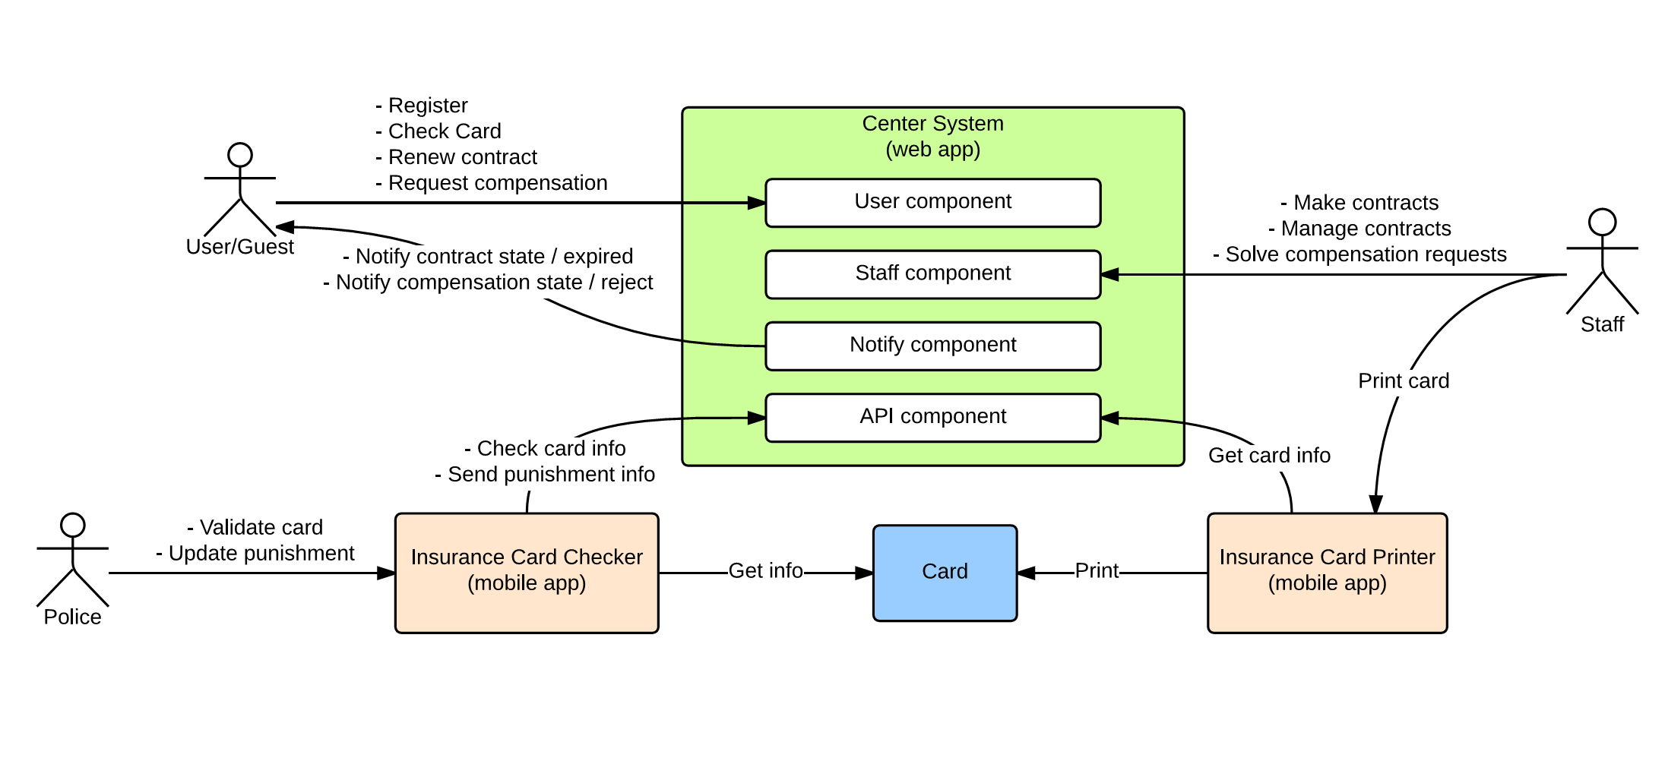

|  |  |  |
| --- | --- | --- |
| Component | | Responsible |
| User component | Register | Nguyễn Chí Kha |
| Check card information |
| Renew contract (with payment) |
| Request compensation |
| Staff component | Create contracts | Nguyễn Hữu Phúc |
| Manage contracts |
| Resolve compensation requests |
| Notify component | Notify contract expiration | Phùng Quang Minh Trí |
| Notify compensation states (approved / rejected) |
| API component | Retrieve card information |
| Update punishment information |
| Check card validation | Đinh Quang Trung |
| IC Checker (mobile app) | Check card validation |
| Send punishment information to API |
| IC Printer (mobile app) | Get card information |
| Print card (write data to NFC card) |